JamboRÍ Programme
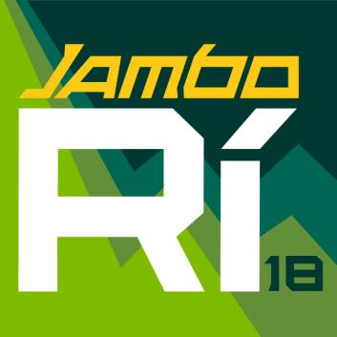

Fellow Scouts,

The JamboRí programme slogan is Rí-CREATE – Rí-IMAGINE – Rí-DISCOVER.

These ideas will help shape an adventure-filled camp of fun, friendship, and challenge, for
hundreds of patrols and crews.

The theme is designed to encourage imagination and innovation for you, as young people, to develop your skills, help in the community, and go on amazing journeys of discovery.

Summer camp is the highlight of the scouting year. In order to help all patrols and crews prepare for the JamboRí and get the most of the

experience, the programme
team are providing resources to help you develop your patrols and crews, to make contact with other groups, and to get a taste of the programme zones.

I hope the JamboRí

programme theme Rí-CREATE

– Rí-IMAGINE – Rí-DISCOVER will inspire you throughout the scouting year ahead to lead an active programme in preparation for this national camp.

Yours in Scouting, Úna O’Grady
JamboRí Programme Lead

Scout Programme

Rí-CREATE – Rí-IMAGINE – Rí-DISCOVER

For the Scouts, Rí-CREATE – Rí-IMAGINE – Rí-DISCOVER will focus on patrols working together to complete teamwork and skills challenges, and make new friends during the camp.

There will be six programme zones. Each subcamp will visit each programme zone for a day during the JamboRí. These zones will be inspired by a trailblazer and their story.

The Programme Zones offer a combination of scouting Adventure Skills, such as water activities and backwoods, and team-work and creative skills, including innovation and community projects. By participating in the programme Scouts will have an opportunity to advance in their Crean Awards and Adventure Skills.

The programme theme is reflected in the Sub-Camps, each of which is named after a fictional place from a story of adventure and discovery. These stories will help build

up the spirit of friendship and
support in each sub-camp. There will also be programme on the subcamps on some evenings.
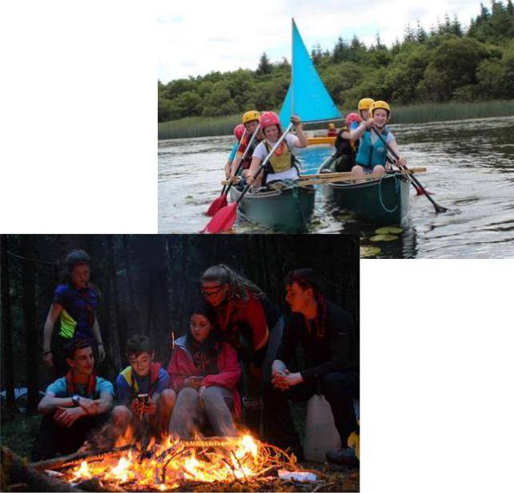

Venture Scout Programme Rí-Create – Rí-Imagine – Rí-Discover

The Venture Scout Programme for the JamboRi is focused on Rí-CREATE – Rí-IMAGINE – Rí-DISCOVER . It is designed to offer Venture Scouts a chance to take on new skills and challenges and to help develop themselves.

There will be three main Venture Scout Programme zones reflecting the theme. These will combine Adventure Skills and initiative activities. Venture Scouts will have their own subcamp which will have evening programmes to help participants mix and make new friends.
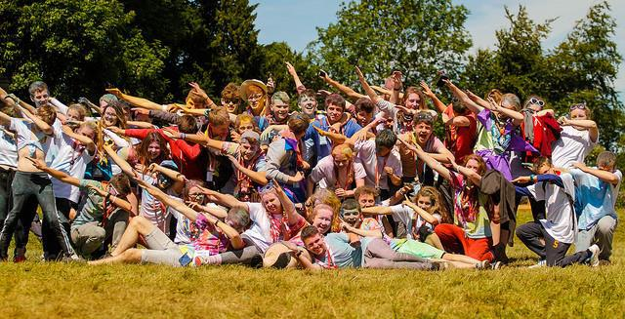

Venture Scouts will also have an opportunity to develop their scouting and leadership skills by participating in three days of service with the Scout Programme. Venture Scouts

will be assisting in running
parts of the Scout Programme Zones or other functions, such as Communications or Logistics, in areas which reflect their interests. This will allow you to mix with others and to advance in your Adventure Skills and Special

Interest areas, which are
especially important for the Venture Scout Chief Scout Award.
